

**SHANDONG UNIVERSITY**

**OF TECHNOLOGY**

**Android Studio Final Project**

**ONLINE EXAMINATION**

**Instructor: Jia Yongxin(贾永新)**

|  |  |
| --- | --- |
| **Class** | Mobile App Development |
| **ID** | 19812502010 |
| **Name** | DAS POLASH CHANDRA |

**Contents**

1. Objective: 2

2. Using Tools: 2

3. Design logic of examination system 2

4. Functionality 3

5. Design 3

**1. Objective:**

The objective of this app is to use a web service interface and such kinds of functional modules like user register, user log-in, Add Test Scheduling, Add Question, View All Test Scheduling, Get Question by Count and Save Test Result. If the user will successfully log in after the user can access the app functionality which is display in the main page.

# **2. Using Tools:**

* Android Studio bumblebee 2021.1.1
* JDK 18
* WebService

# **3. Design logic of examination system**

1. All students can register one or more new users, and go to the main interface after successful login.
2. All available test plans are displayed in the main interface. Students can click a test plan to extract test questions and start the test.
3. After the examination, calculate the correct number of questions on the mobile phone, and then write the list of questions, students' answers and other information back to the database.
4. Students can add their own test plans.
5. Students can add the question information in the examination question library by themselves

# **4. Functionality**

I have used such kinds of functionalities in my Online Examination System Android App

* User Register
* User Login
* Add Test Scheduling
* Add Question
* View All Test Scheduling
* Get Question by Count
* Save Test Result

# **5. Design**

**Register Page:**

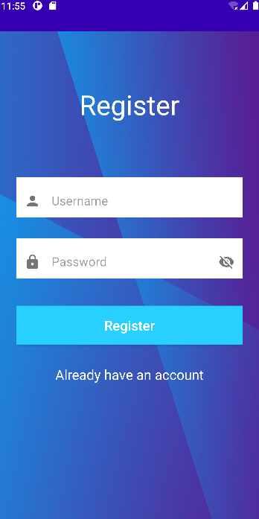 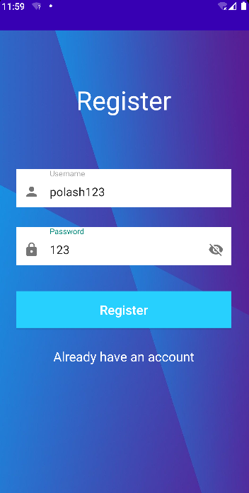

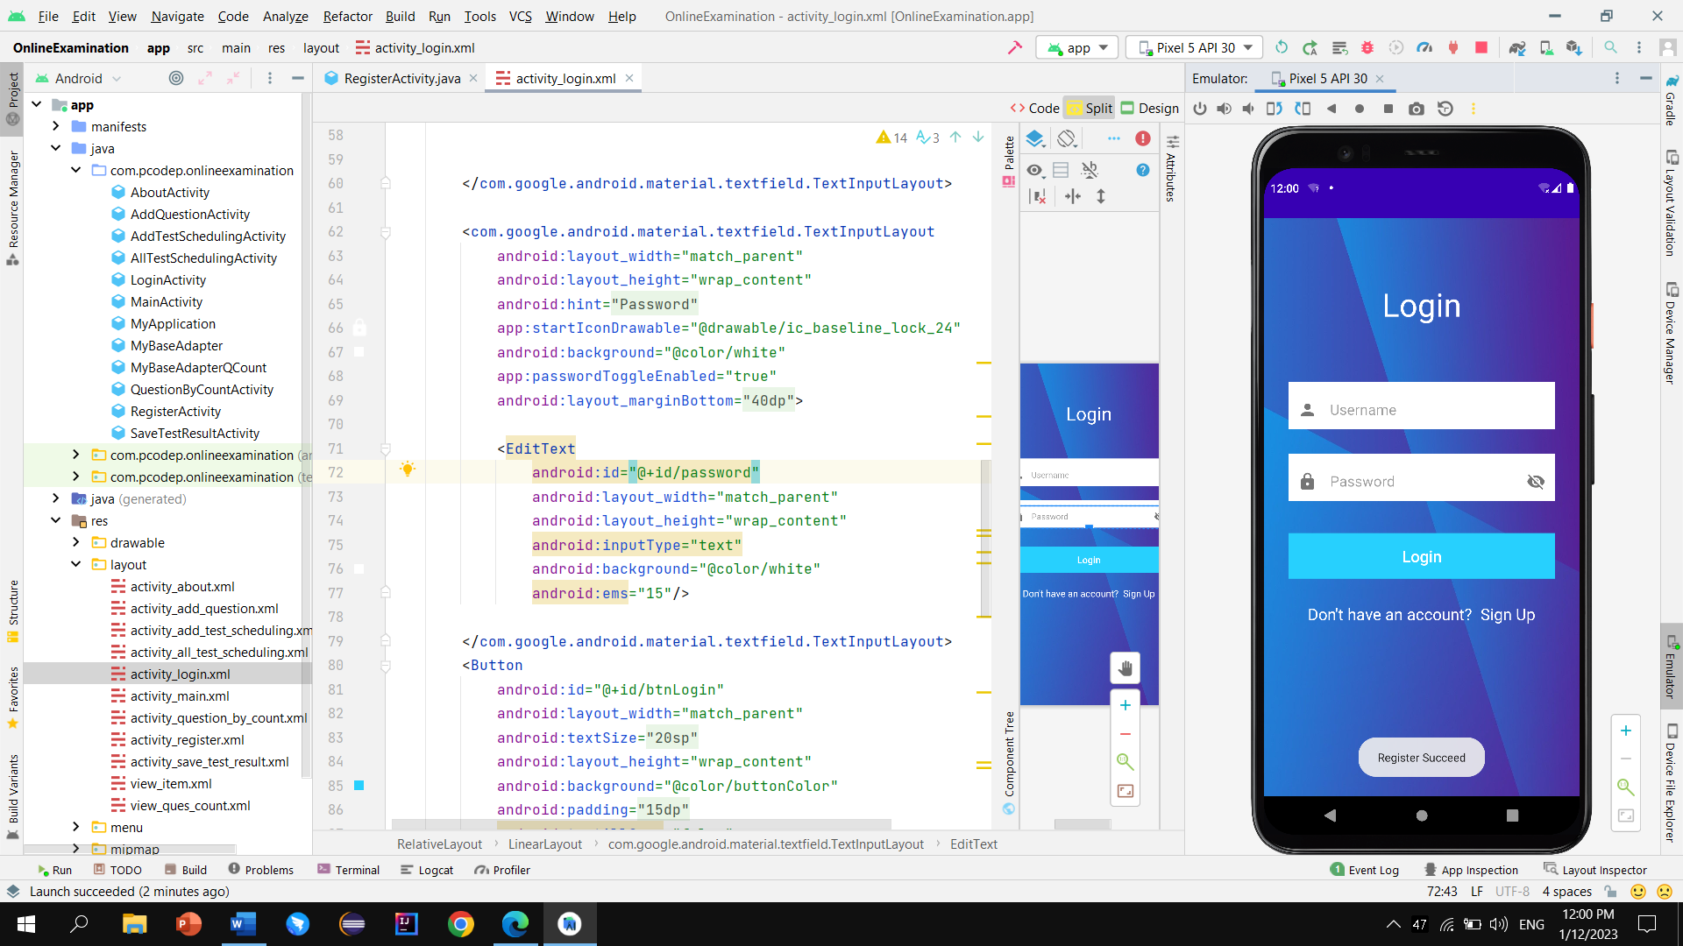

**Login Page:**

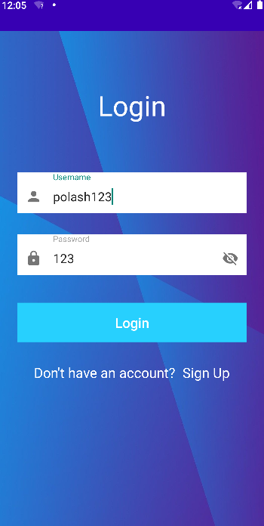 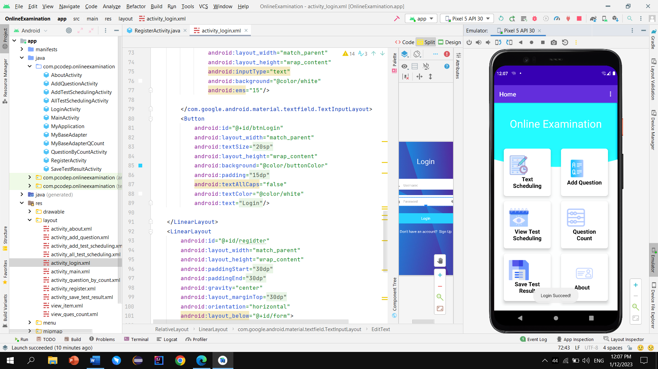

**Home Page:  
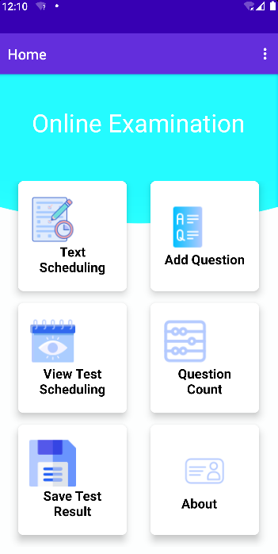**

**Text Scheduling:**

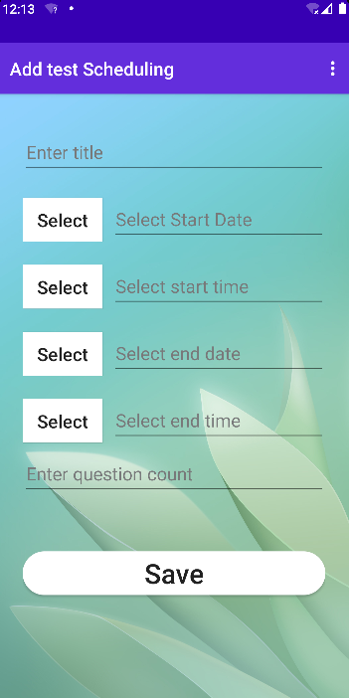 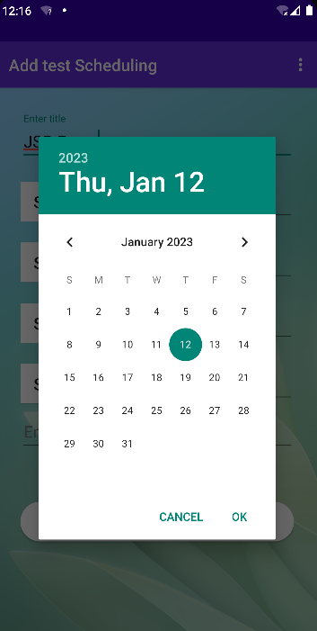

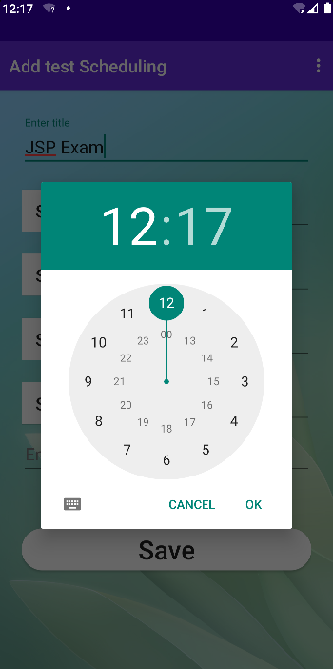 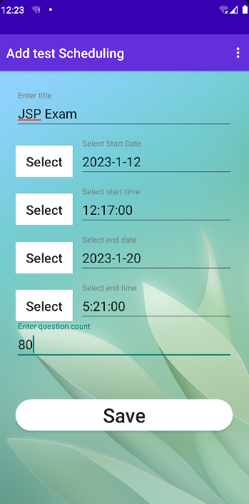

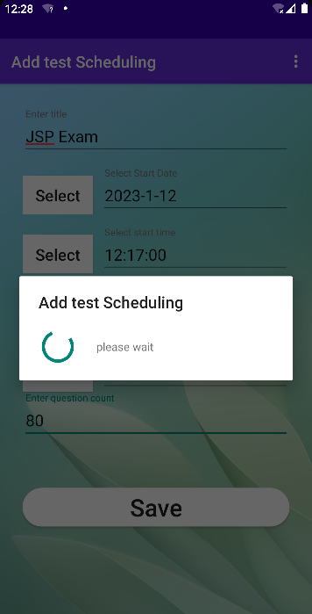 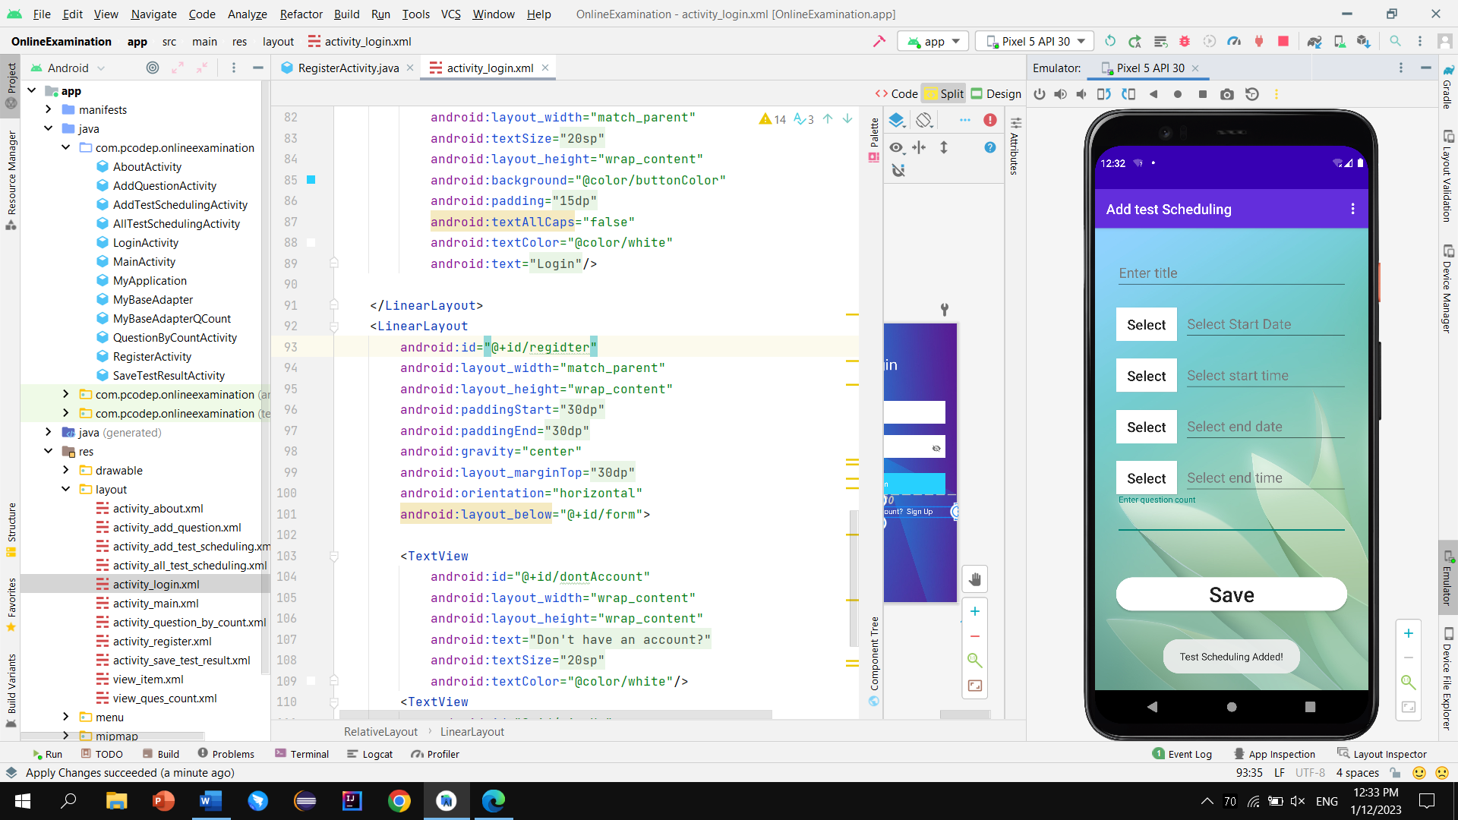

**Add Question:**

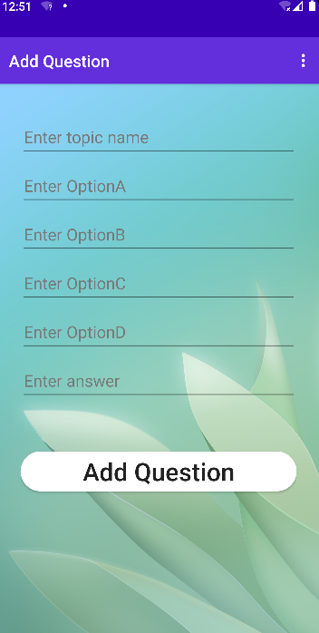 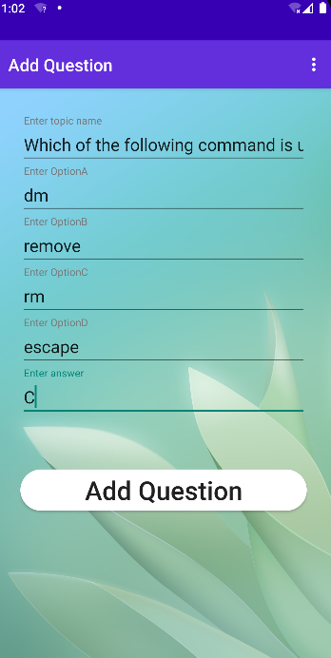

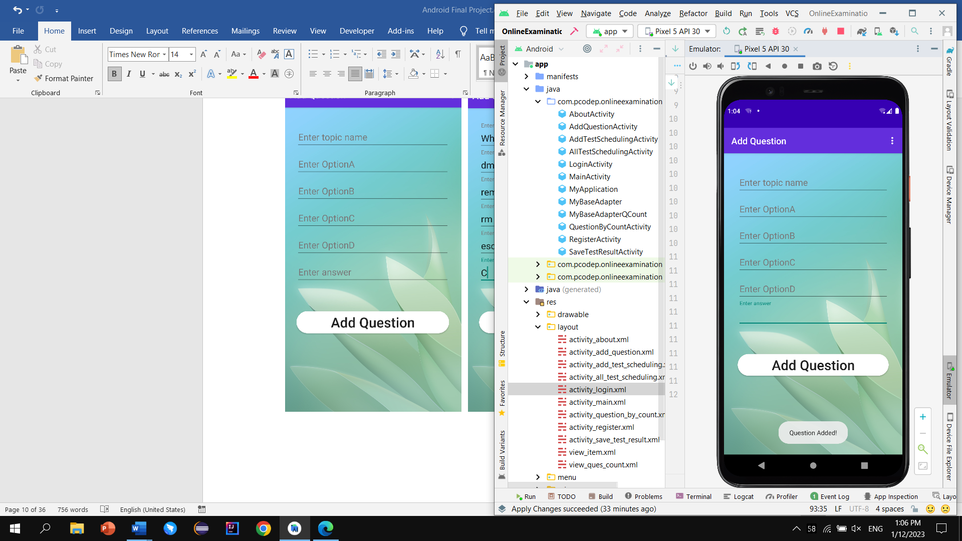

**View Test Scheduling:**

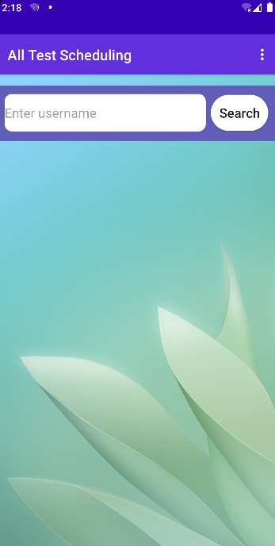 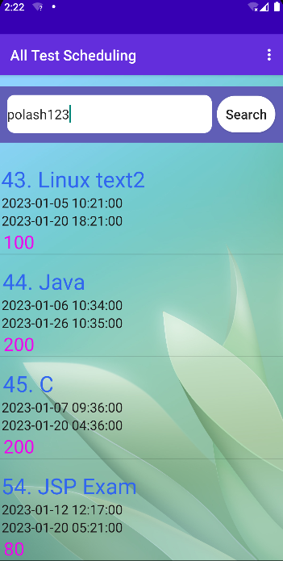

**Question by Count:**

 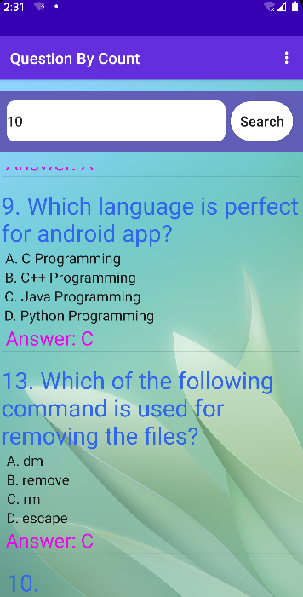

**Save Test Result:**

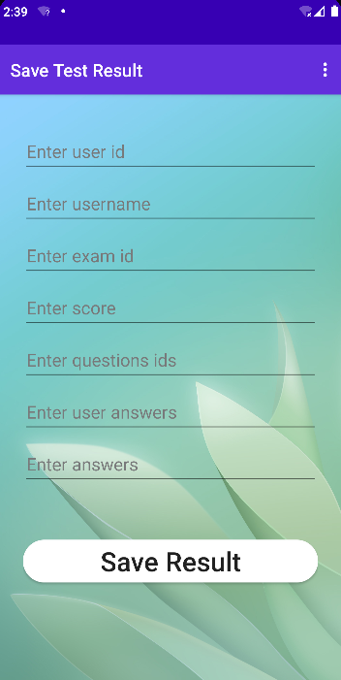 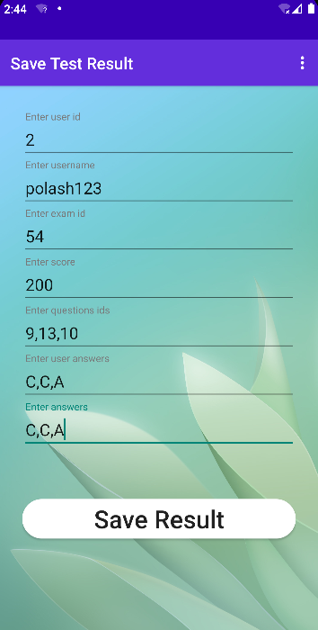

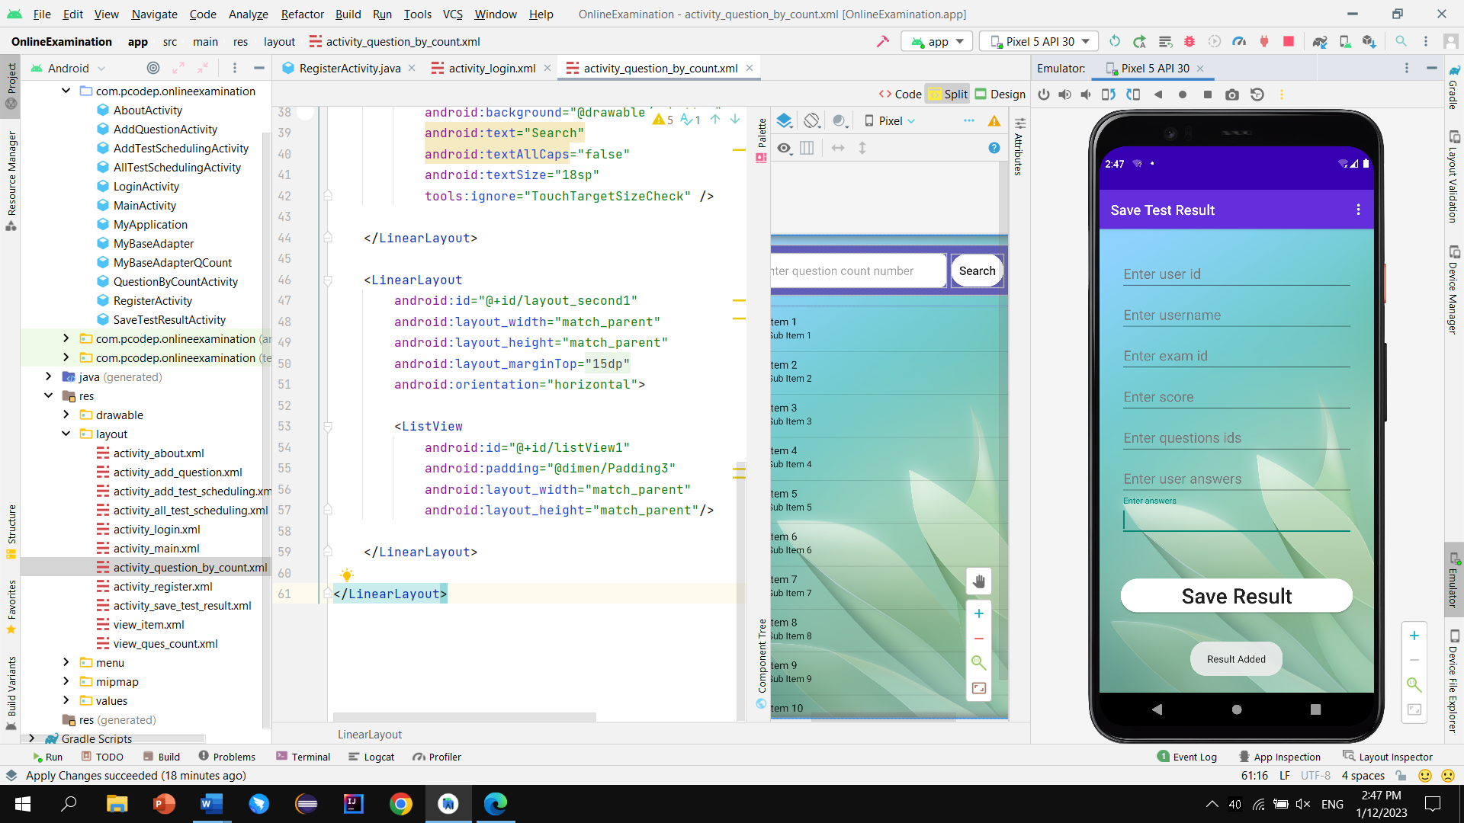

**End**